**DASHBOARD DESIGN AND VISUALISATION**

**Task-**

**Data analysis and report visualisation:**

1. **Uploading the Excel file data from Moodle Unit Website to Power Bi:**

* First Opening the Power BI Desktop.
* Clicking "Home" in the ribbon.
* Select "Get Data" and choose the appropriate data source or use Web if the Moodle unit provides a web link.
* Follow the prompts to connect and import the data into Power BI.

1. **Adding Title and Logo into the Power BI report:**

* Creating a title "American Bank" by using “Text box” in the “Home tab”.
* Adding the logo and importing the image from “Home tab”.



1. **Using card on report creating a measure called "Total Balance" and also changing the background colour of the report:**

* Go to “Visualization” and select format your report page.
* In the "Visualization" tab, click on "Canvas Background" to change the background colour.
* Creating a total balance measure. Right-click on the table name, Select "New Measure," and enter the formula for the condition.
* Select the card and drag the condition **"Total Balance"** for the card.



1. **Creating "House Owner Balance" and "Rental Balance" measures by using card on Power BI:**

* The steps are going to be same as the 3rd, creating a "House Owner Balance" and a "Rental Balance" measure. Right-click on the table name, Select "New Measure," and enter the formula for the conditions.
* Select the card and drag the both conditions for the card.

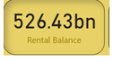 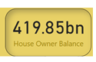

1. **Create "Male Balance" and "Female Balance" measures by using card on Power BI:**

* Same as the previous one, creating "Female Balance" and a "Male Balance" measure. Right-click on the table name, Select "New Measure," and enter the formula for the conditions.
* Select the card and drag the both conditions for the card.

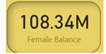 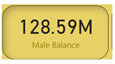

1. **Creating a Slicer for the Education:**

* In the visualization click on the slicer.
* After selecting the slicer select the education column to add into the slicer.

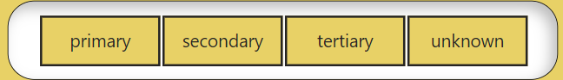

1. **Creating a Slicer for the Job classification:**

* Select the slicer and then select the Job classification column to add into the slicer.

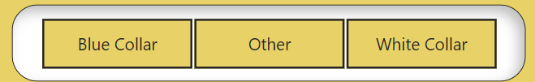

1. **Creating a Donut chart of Total Balance by Job Classification:**

* Creating **"**Total balance” measure for the job classification.
* To represent this data use the Donut chart.

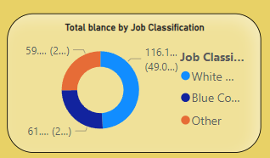

1. **Creating a Pie chart of Total Balance by Education:**

* Creating "Total balance” measure for the Education.
* To represent this data use the Pie chart.

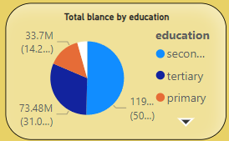

1. **Creating a “Clustered column” chart of Total Balance by Education:**

* Creating "Total balance” measure for the Education.
* To represent this data use the Clustered column chart.

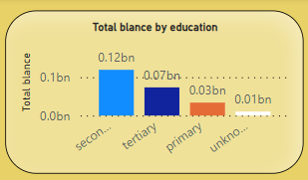

1. **Creating a Stacked bar chart of Total Balance by Marital status:**

* Create a measure to calculate Total Balance by Marital Status.
* To represent this data use the stacked barchart.

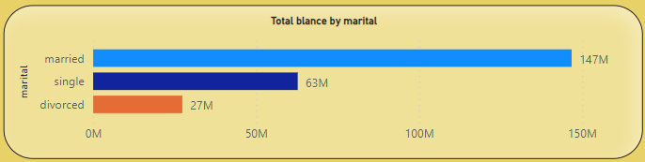

1. **For balance and state Create a map using customer ID:**

* In the visualization click on the Map.
* Select the Map and drag Balance, and State into the Map.

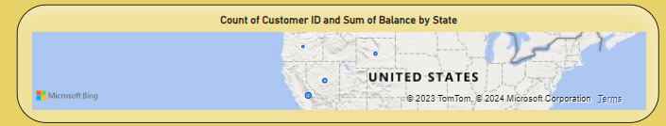

1. **Using loan default information creating a Stacked bar chart:**

* To show Loan Default Information Create a measure.
* To represent this data use the stacked bar chart.

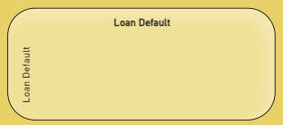

1. **Creating a stacked column chart to show the Martial status using Customer ID:**

* For Marital Status create a measure for Customer ID.
* To represent this data use the stacked Column chart.

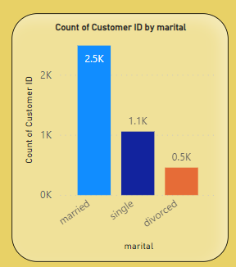

1. **Analysing the complete data and then writing the conclusion:**

* Extracting data from the data visualisation.
* By observing the data concluding patterns, trends, or insights.
* Explaining the importance of data visualisation in data analysis.